Companion Document for Week 5

Detailed steps for the Machine Learning in Azure segments

- Import the data:

Drag the Import Data box to the experiment. In the Data source line, select Web URL vis HTTP. In the Data source URL line, enter the following url: https://docs.google.com/spreadsheets/d/1SNfa8yWRDQ9aU5cVQMdUdx8D64gYq06iTh0D6QlHq44/pub?gid=104186993&single=true&output=csv. In the Data format line, select CSV. Check the box in front of CSV or TSV has header row and Use cached results. Click Run.

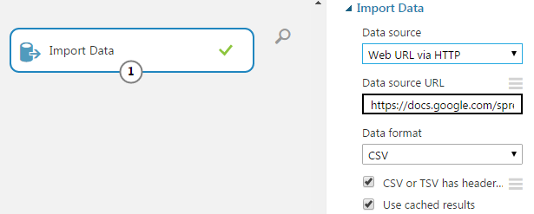

- Select necessary data to be use

Drag the Select Columns in Dataset box and connect it to the Import Data box. Click Launch column selector option. Select the columns with name DEFAULT, LIMIT_BAL, AGE, MARITAL, and PAY_1.

- Split the dataset into training set and test set

Drag the Split Data box and connect it to the Select Columns in Dataset box. Set the value of Fraction of rows in the first output dataset to be 0.7; this means that 70% of the data will be used as the training set and the remaining 30% as the test set.

- Drag the Two-class Decision Forest box. Set the value of Number of decision trees to be 1. Set the Maximum depth of the decision trees to be 4.

- Drag the Train Model box. Connect its left inlet with the Two-class Decision Forest box. Connect its right inlet to outlet 1 of the Split Data box.

- Drag the Score Model box. Connect its left inlet with the Train Model box. Connect its right inlet to outlet 2 of the Split Data box.

Drag the Evaluate Model. Connect its left inlet with the Score Model box.

- You can find the trained model from the outlet of the Train Model box. You can evaluate the quality of the model by looking at the output of the Evaluate Model box.

